**Ссылка на GitHub:** [**https://github.com/DenisNyux/computer_graphics**](https://github.com/DenisNyux/computer_graphics)

**Язык программирования:** Python 3.7 + библиотека tkinter

Рисование

**Скриншот:**

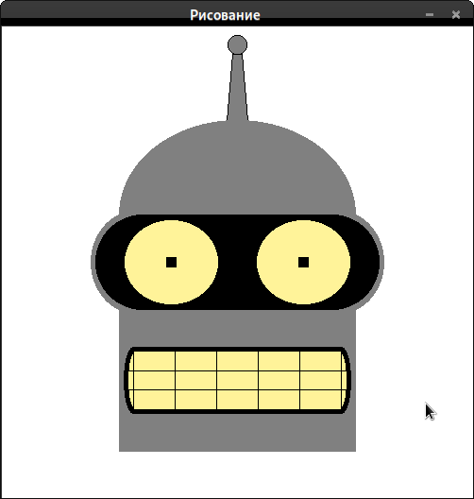

**Код процедуры:**

**def draw():**

**# Антенна**

**canv.create_oval(dec_to_scr((-1, 22)), dec_to_scr((1, 24)), fill='gray', outline='black')**

**canv.create_polygon(dec_to_scr((-0.5, 22)), dec_to_scr((-1.1, 15)), dec_to_scr((1.1, 15)), dec_to_scr((0.5, 22)),**

**fill='gray', outline='black')**

**# Фон головы**

**canv.create_oval(dec_to_scr((-12.5, -5)), dec_to_scr((12.5, 15)), fill='gray', outline='gray')**

**canv.create_polygon(dec_to_scr((-12.5, 5)), dec_to_scr((12.5, 5)), dec_to_scr((12.5, -20)),**

**dec_to_scr((-12.5, -20)), fill='gray', outline='gray')**

**# Глаза, задний фон**

**canv.create_oval(dec_to_scr((5.5, -5.5)), dec_to_scr((15.5, 5.5)), fill='gray', outline='gray')**

**canv.create_oval(dec_to_scr((-15.5, -5.5)), dec_to_scr((-5.5, 5.5)), fill='gray', outline='gray')**

**canv.create_polygon(dec_to_scr((-10.5, -5.5)), dec_to_scr((10.5, -5.5)), dec_to_scr((10.5, 5.5)),**

**dec_to_scr((-10.5, 5.5)), fill='gray', outline='gray')**

**# Глаза**

**canv.create_oval(dec_to_scr((5, -5)), dec_to_scr((15, 5)), fill='black', outline='black')**

**canv.create_oval(dec_to_scr((-15, -5)), dec_to_scr((-5, 5)), fill='black', outline='black')**

**canv.create_polygon(dec_to_scr((-10, -5)), dec_to_scr((10, -5)), dec_to_scr((10, 5)),**

**dec_to_scr((-10, 5)), fill='black', outline='black')**

**# Глазные яблоки**

**canv.create_oval(dec_to_scr((2, -4.5)), dec_to_scr((12, 4.5)), fill='#fff399')**

**canv.create_oval(dec_to_scr((-12, -4.5)), dec_to_scr((-2, 4.5)), fill='#fff399')**

**canv.create_rectangle(dec_to_scr((6.5, -0.5)), dec_to_scr((7.5, 0.5)), fill='black')**

**canv.create_rectangle(dec_to_scr((-7.5, -0.5)), dec_to_scr((-6.5, 0.5)), fill='black')**

**# Рот задний фон**

**canv.create_oval(dec_to_scr((-12, -16)), dec_to_scr((-10, -9)), fill='black', outline='black')**

**canv.create_oval(dec_to_scr((10, -16)), dec_to_scr((12, -9)), fill='black', outline='black')**

**canv.create_rectangle(dec_to_scr((-11, -16)), dec_to_scr((11, -9)), fill='black', outline='black')**

**# Рот**

**canv.create_oval(dec_to_scr((-11.5, -15.5)), dec_to_scr((-10, -9.5)), fill='#fff399', outline='#fff399')**

**canv.create_oval(dec_to_scr((10, -15.5)), dec_to_scr((11.5, -9.5)), fill='#fff399', outline='#fff399')**

**canv.create_rectangle(dec_to_scr((-11, -15.5)), dec_to_scr((11, -9.5)), fill='#fff399', outline='#fff399')**

**# "Зубы"**

**canv.create_line(dec_to_scr((-11.75, -11.5)), dec_to_scr((11.75, -11.5)))**

**canv.create_line(dec_to_scr((-11.75, -13.5)), dec_to_scr((11.75, -13.5)))**

**canv.create_line(dec_to_scr((-11, -9)), dec_to_scr((-11, -16)))**

**canv.create_line(dec_to_scr((-6.6, -9)), dec_to_scr((-6.6, -16)))**

**canv.create_line(dec_to_scr((-2.2, -9)), dec_to_scr((-2.2, -16)))**

**canv.create_line(dec_to_scr((2.2, -9)), dec_to_scr((2.2, -16)))**

**canv.create_line(dec_to_scr((6.6, -9)), dec_to_scr((6.6, -16)))**

**canv.create_line(dec_to_scr((11, -9)), dec_to_scr((11, -16)))**